

Data Warehousing and Business Intelligence (CT-472)

Healthcare Data Warehouse System

Department of Computer Science & Technology

Group Members:
- Neha Laeeq (DT-22002)
- Talal Khan (DT-22043)
- Shayan (DT-22037)
- Ahmed Hassan (DT-22041)

Table of Contents
1. Abstract: 3
2. Introduction: 3
3. Project Objectives: 3
4. Data Sources: 4
5. Methodology: 4
5.1. ETL Pipeline (Extract, Transform, Load): 4
5.2. Data Warehouse Design (Star Schema): 5
5.3. Data Storage: 6
5.4. Data Access & Visualization: 6
5.5. Implementation: 7
6. Results & Discussion: 7
7. Expected Benefits: 8
8. Conclusion: 8
9. Future Work: 8

Healthcare Data Warehouse Implementation

Abstract:

This project focuses on designing and implementing a Healthcare Data Warehouse System that consolidates global health-related data from multiple sources — including CSV files and APIs — into a centralized analytical platform.
The goal is to enable hospitals, researchers, and policymakers to make data-driven decisions by integrating, cleaning, transforming, and organizing healthcare data efficiently.
The system uses a Python-based ETL (Extract, Transform, Load) pipeline that gathers data from a global-health-statistics.csv dataset and a live COVID-19 API, performs data cleaning and validation, and stores the results in a Star Schema within a SQLite data warehouse.
Finally, the warehouse supports analytical reporting, visualization, and machine learning applications such as clustering and anomaly detection to uncover health trends and performance insights across countries, demographics, and time periods.

Introduction:
Healthcare organizations collect vast amounts of data daily from hospitals, surveys, and public health systems. However, this data often resides in multiple, incompatible systems, limiting its usability. This project addresses the problem by developing a Healthcare Data Warehouse (DWH) that integrates, standardizes, and structures heterogeneous healthcare data for efficient querying and analysis.
The system uses ETL automation in Python to extract and transform datasets before loading them into a Star Schema database. This design enables clear relationships between diseases, demographics, time, and healthcare resources.
Through data visualization and analytical techniques, the DWH provides valuable insights into disease trends, treatment costs, and healthcare access worldwide.

Project Objectives:
- Centralized Storage: Combine multiple datasets (CSV, API) into a unified warehouse.
- Data Quality & Validation: Perform automated profiling, missing-value handling, and duplicate removal.
- Efficient Analysis: Implement a Star Schema structure to support fast queries and visualizations.
- Automation & Scalability: Design a reusable Python ETL pipeline with logging, metadata tracking, and data exports.
- Analytical Applications: Apply clustering and anomaly detection ML models to identify health trends.
- Business Intelligence Integration: Generate reports that can be visualized using Power BI or Python libraries.

Data Sources:
The project integrates multiple healthcare data sources to simulate real-world complexity.
Source Type | Description | Example Attributes
CSV (Global Health Statistics) | Contains international healthcare and disease indicators | country, disease_name, prevalence_rate, mortality_rate, healthcare_access, doctors_per_1000
API (COVID-19 Data) | Fetches live COVID-19 statistics for all countries | country, cases, deaths, recovered, population, continent
Synthetic/Derived Data | Created during transformation for demographics, time, and disease mapping | age_group, gender, year
All sources were extracted via Python scripts in the ETL workflow, standardized, and integrated into the data warehouse.

Methodology:

We used multiple data sources to populate the warehouse. The primary source is a large CSV file (global-health-statistics.csv) containing global health metrics (e.g. disease rates, demographics) spanning multiple countries and years. In addition, we integrated live COVID-19 data via a public REST API (https://disease.sh/v3/covid-19/countries) to include current pandemic statistics per country. These heterogeneous sources demonstrate how data warehouses ingest flat files and APIs. (In a broader scenario, one could also include OLTP databases or other APIs for comprehensive coverage.)

ETL Pipeline (Extract, Transform, Load):

The core of the project is a Python-based ETL pipeline, following standard best practices. In the extract phase, we read the CSV file using Pandas and fetched the COVID-19 JSON data via requests. In the Transform phase, we cleaned and normalized the data: column names were standardized; string fields stripped of whitespace; duplicate records removed; and missing numeric values filled (e.g. with median values). We then created dimension and fact tables by slicing and merging the datasets. For example, we built a DimCountry table (including country socio-economic attributes), DimDisease, DimDemographics, DimTime, and DimCovidStats tables, each assigned a surrogate key. The fact table (FactHealthOutcomes) was formed by joining the cleaned data to all dimension keys, containing measures such as incidence rate, mortality rate, etc. In the Load phase, we connected to a SQLite database and created the schema (fact and dimension tables) before loading the data. Our pipeline code includes logging at each stage (Extraction, Transformation, and Loading) to report progress and catch errors. A summary of the ETL steps:

- Extract: Read 1,000,000 rows from the global health CSV and retrieve COVID-19 data for 231 countries.
- Transform: Standardize and clean fields, handle missing values, drop duplicates. Generate dimension tables (country, disease, demographics, time, covid) and a central fact table with foreign keys to each dimension.
- Load: Create relational tables in SQLite matching the star schema. Bulk-insert dimension and fact data. Create indexes on key columns for query performance.

Data Warehouse Design (Star Schema):

We adopted a star schema design, a common data warehouse modeling technique. In this schema, a large central fact table contains the primary health outcome measures, surrounded by dimension tables that describe contextual attributes. This makes queries more intuitive and performant: analysts can “slice and dice” facts using dimension attributes like country, disease, time, etc. For example, one can easily query total incidence rates by country and year by joining the fact table to the DimCountry and DimTime dimensions. Star schemas are widely used in BI scenarios. In our implementation, the dimension tables include:

- DimCountry (country ID, name, and socioeconomic attributes)
- DimDisease (disease ID, name, category, treatment type)
- DimDemographics (age group and gender categories)
- DimTime (year ID and year)
- DimCovidStats (COVID stats per country from the API)

These dimension tables link to the central FactHealthOutcomes table (via foreign keys), which holds measures such as prevalence rate, mortality rate, and so on. This star layout simplifies analytics: as one source observes, “fact tables provide quantitative data (measures) for analysis, while dimension tables enrich these measures with descriptive attributes”. The schema was implemented in SQLite with appropriate PRIMARY KEYs and FOREIGN KEY constraints, and indexes on foreign keys to speed up joins

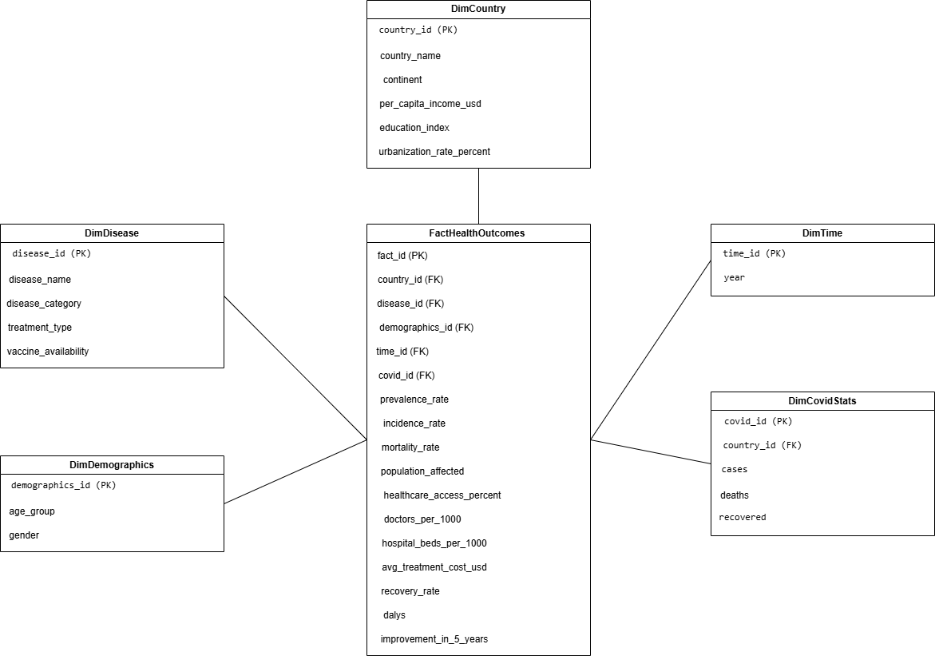

Data Storage:

We used a SQLite database file (global_health_datawarehouse.db) as the data warehouse store.
SQLite was chosen for simplicity (it requires no server) but still enforces a relational schema. The database resides in the data_warehouse/ directory. During the load phase, we executed SQL DDL to create each dimension and fact table. All data-frames were then written into the corresponding tables. The tables were defined to match our data model (e.g. numeric types for rates, integer keys, text for names) and indexed on key columns. This SQLite warehouse now holds all integrated data in a structured form, ready for querying. (In a production system, a more scalable engine like PostgreSQL, Redshift, or BigQuery could be used).

Data Access & Visualization:

Once loaded, the warehouse can be accessed via SQL or connected to BI tools. Thanks to the star schema, popular analytics and visualization tools (Power BI, Tableau, QlikView, etc.) can easily import the tables for dashboard building. For example, one could create dashboards showing time trends of disease metrics by region, or drill down from aggregate KPIs into specific diseases or countries. Data analysts can also use Python (with pandas, SQLAlchemy, etc.) to query the SQLite database and generate plots (matplotlib/plotly) or compute further metrics. The star schema design specifically “is a preferred design for BI tools such as Power BI, Tableau, and QlikView due to its simplicity and performance”, which facilitates creating interactive reports.

Implementation:

- data/ – Contains input files. The key file is global-health-statistics.csv (the raw source data).
- etl.ipynb – A Jupyter notebook implementing the ETL pipeline. This notebook contains all code for extraction, transformation, loading, and some validation queries.
- Data_warehouse/ - Contains outputs. After running the ETL, the SQLite database global_health_datawarehouse.db is created here, along with an exports/ subfolder for any query results.
- logs/ - Execution logs are written here to document each ETL run.

The Jupyter notebook (etl.ipynb) shows the entire pipeline. It first initializes directories (creating data, data warehouse etc.), then logs the start of the ETL job. In Phase 1, it loads the CSV (1,000,000 records) and fetches the COVID-19 API. In Phase 3 it performs transformations, reporting that it created dimension tables of sizes (for example, 20 countries, 1,760 diseases, 12 demographics categories, and 25 years) and a fact table of 1,000,000 records. In Phase 4 it creates the SQLite schema and loads all tables (in the notebook output, each dimension and fact table row count is logged). The final result is a file data_warehouse/global_health_datawarehouse.db containing the complete data warehouse.

Results & Discussion:

Upon completion, the data warehouse is populated with the integrated data. Key expected outcomes include:
- Unified data repository. All relevant global health data now resides in one database, enabling comprehensive queries (e.g. correlating socio-economic factors with disease rates).
- Operational dashboards. The warehouse can support BI dashboards. For example, one could build a real-time COVID-19 dashboard that joins the COVID dimension to historical health trends. Or visualize trends in incidence rates over years by country. This eases strategic monitoring of health KPIs.
- Analytics and machine learning. The structured data can feed predictive models. Analysts can export training datasets from the warehouse – for instance, using country and demographic features to predict disease outbreaks. The prepared data is suited for clustering (e.g. grouping countries by health profiles) or classification (e.g. predicting mortality risk). Even deep learning models could be trained on this consolidated data for complex pattern discovery. As industry sources note, data warehouses are often used to “prepare data for machine learning (ML)” and advanced analytics
.
During development, we ran several validation queries on the warehouse (as shown in the notebook). For instance, we computed “Top 10 Diseases by Average Mortality Rate” and identified the countries with highest DALYs (disability-adjusted life years). These sample analytics demonstrate the warehouse’s power to generate insights. In practice, end users could create interactive dashboards (e.g. in Tableau) or schedule SQL reports to answer business questions.

Expected Benefits:
- Improved decision-making. By consolidating all health data into one source of truth, stakeholders get a consistent view of metrics (such as incidence, prevalence, mortality). This unified dataset supports more informed public health strategies.
- Faster, reliable reporting. Pre-modeling the data into a star schema speeds up queries. Common analytics (like summing incidence by region and year) run efficiently against the fact/dimension layout, reducing report generation time. In effect, we have “reduced query times when gathering data and processing analytics” by organizing data for analytical use.
- Data quality and transparency. The ETL pipeline enforces cleaning rules, so the warehouse data is accurate and standardized. This consistency means reports are trustworthy across departments.
- Scalable and extensible architecture. The modular ETL design and schema allow new data sources or additional dimensions to be added without reworking everything. For example, one could later incorporate another API or new health surveys. The SQLite-based solution can be migrated to a larger RDBMS or cloud warehouse (e.g. PostgreSQL, Snowflake) if data volume grows.
- Enables advanced analytics. With cleaned, integrated data at hand, the organization can more easily apply advanced tools. As one source states, data warehouses “facilitate BI, analytics, reporting, data applications, [and] preparing data for machine learning” . Our warehouse primes the data for these next steps (e.g. training deep learning models on health trends).

Conclusion:

This project successfully built a complete data warehouse for global health data. We extracted and unified data from multiple sources, applied rigorous cleaning and modeling, and loaded everything into a star schema in SQLite. The result is a ready-to-use analytical database. Through this work, we demonstrated how data warehousing techniques (ETL pipelines, dimensional modeling) can transform raw data into strategic information. Stakeholders can now run BI reports or analytics on the comprehensive dataset. The project meets its goals of centralizing data, ensuring quality, and enabling insights.

Future Work:

Several enhancements could extend this foundation. For real-time data integration, one could integrate streaming data sources (e.g. message queues or change-data-capture) to update the warehouse continuously rather than batch CSV loads. Adopting a cloud data warehouse (Snowflake, BigQuery, Redshift, etc.) would provide elastic scalability and built-in performance optimizations. These modern platforms often include native support for AI/ML and auto-scaling, aligning with trends in intelligent warehousing. Finally, advanced analytics could be layered on top: for example, using deep learning to detect emerging health patterns, or adding generative AI tools to query the warehouse in natural language. As AI becomes integral to data platforms, future work might involve embedding ML pipelines that train on the warehouse data for predictive health models.

